**CRUD EXAM – Adam Simon**

1. **Frontend: I have created the interface using Angular, Bootstrap, and FAKE json API for testing.**

* First the Login and Signup interface
* With a local host <http://localhost:4200/login>
  + If not yet signup click link below the submit button.
  + If already registered direct login

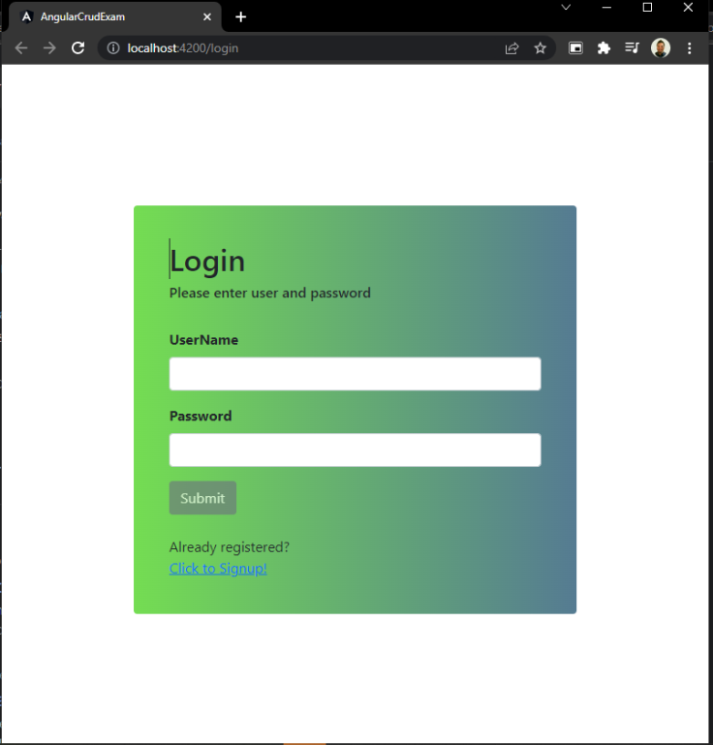

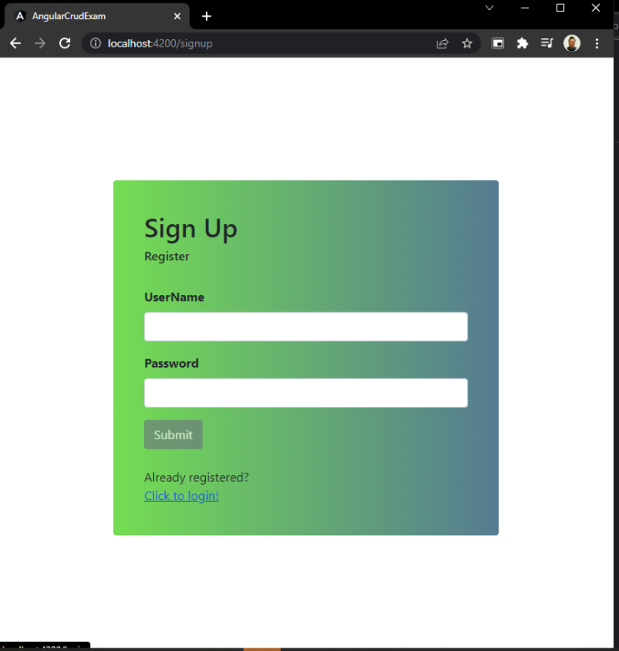

* + Fake json record for userlog and user signup
  + Local host <http://localhost:3000/signupUser> for the post record

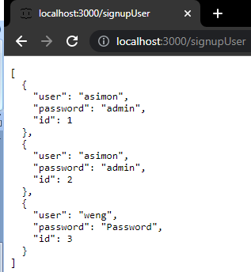

* + For the main dashboard I have created Login, Add user, Edit, Delete, read all record.

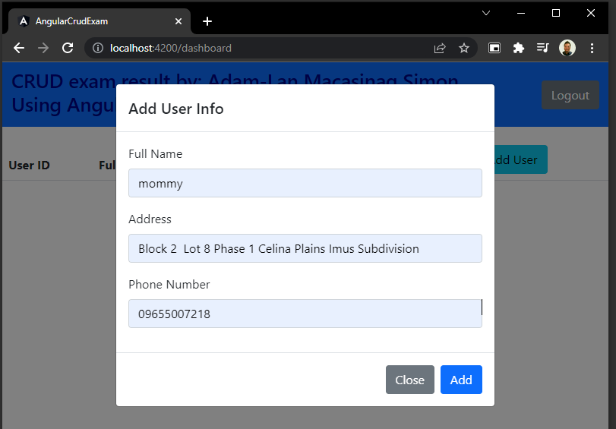

* + For MySql Database for all record, login and logout functionality both are working on Angular fake Jason and Swagger.
  + For Edit and Delete Function are working on Fake json and interface, but when I’m converting to swagger API the time is already up and I need to create instruction.

1. **Backend: I have use ASP.net Core 3.1 using swagger for API.**

* Install NuGet Package:
  + Microsoft EFC
  + Microsoft EFC.Relational
  + Pomelo EFC MySql
  + Swashbuckle (for Swagger)
* Made changes and conversion on Fake json API to Swagger API at frontend Angular.

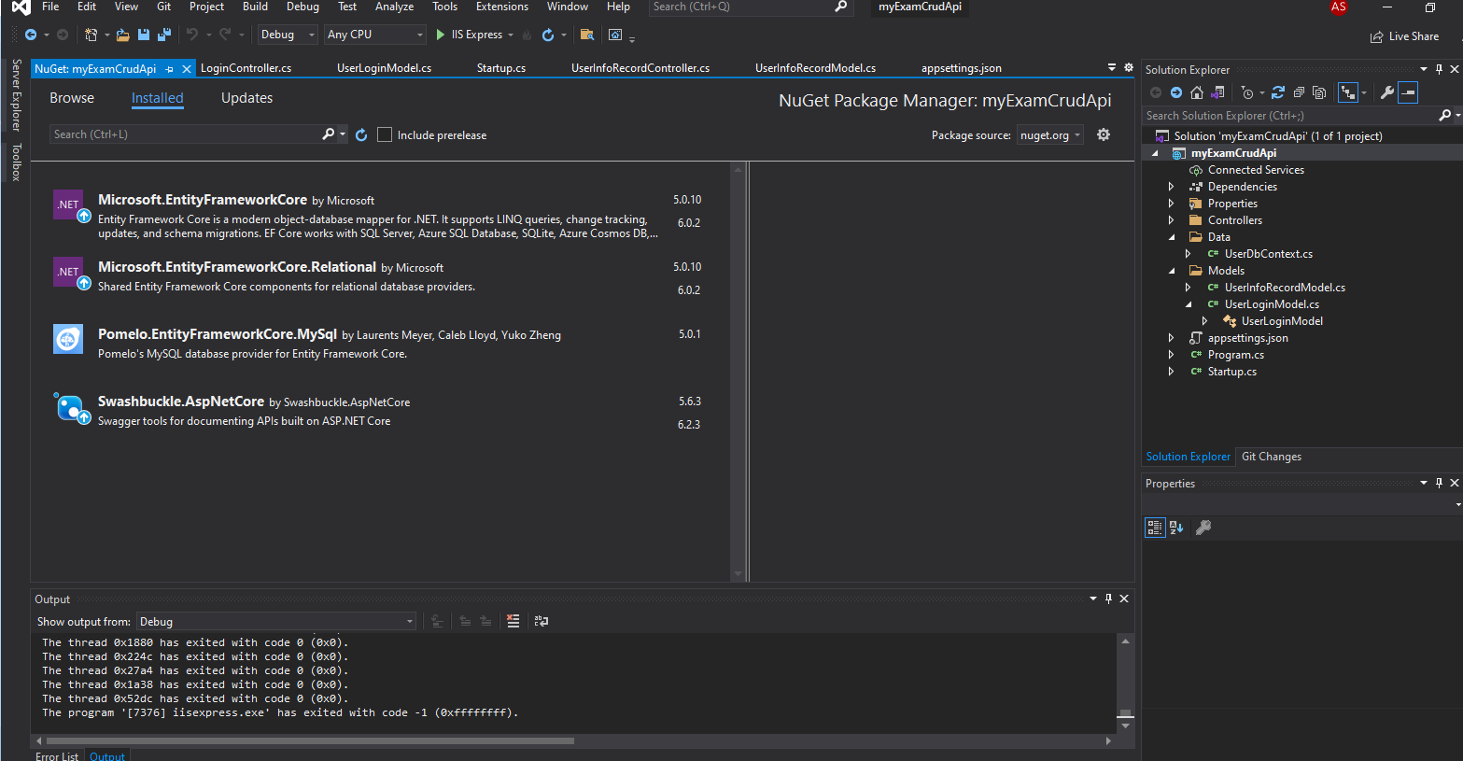

* For API local host <https://localhost:44320/swagger/index.html>
* I created API posting for Login and UserInfoRecord

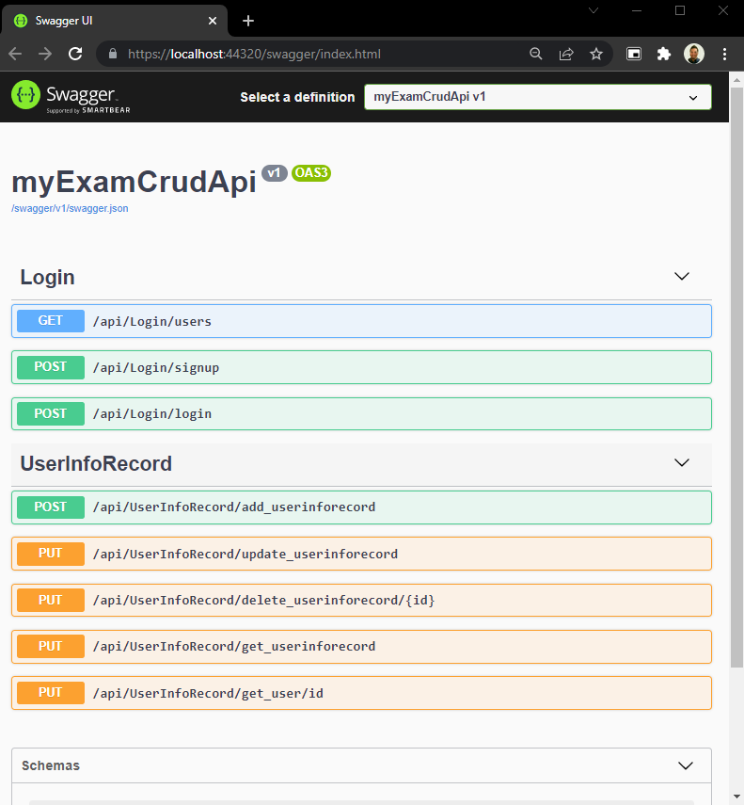

1. **Database: Successfully created and working both manual and swagger API**

**(Angular and .Net Core)**

* Created database name: **mycrudexamdb**
* Created tables:
  + **tbluserinforecord** – For user record container
  + **tbluserlogin** – For login info container

